However In the case of VSAN I run into a situation where I could not get the disks visible after simply **deactivating VSAN.**You can't simply deactivate VSAN and hope to recover the local disks. There are some further steps necessary. I thought that an article to recap the necessary steps shall do it.

How to delete VSAN datastore you'll need to:

**01.** Evacuate all the VMs out of the VSAN datastore.

**02.** Turn OFF VMware HA.

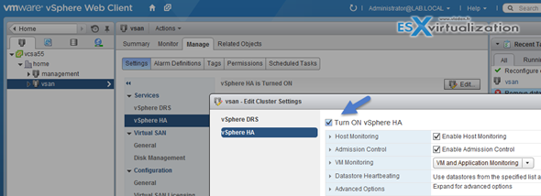

**03.** Delete all VSAN disk groups **Individually**

[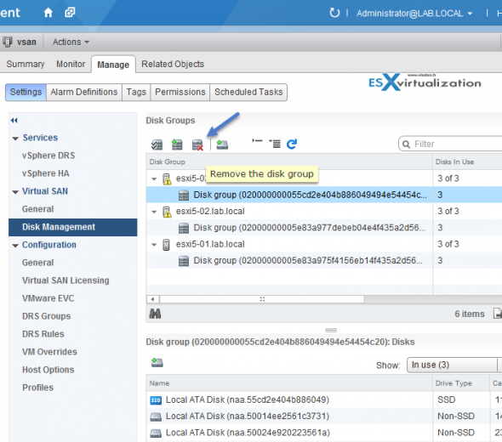](https://www.vladan.fr/wp-content/uploads/images/vsan02.png)

Once done (for each of the hosts participating in the VSAN cluster),  the local disks are available to be re-used…. Here is the screenshot from one of my ESXi hosts.

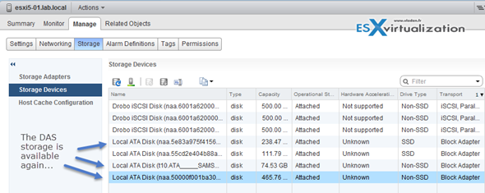

**04.** Deactivate VSAN cluster. At the Cluster level > Manage > Virtual SAN > General

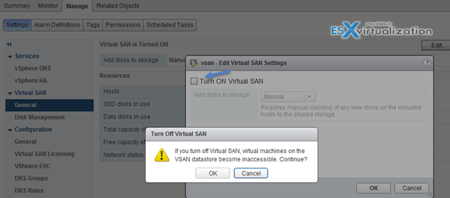

**05.** Re-enable VMware HA.

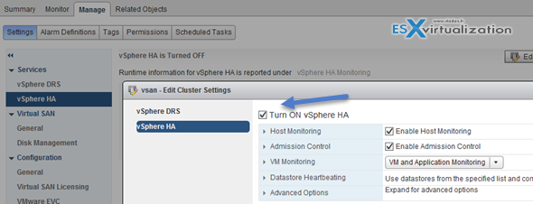

And by checking the datastores you can see that the VSAN datastore is gone.

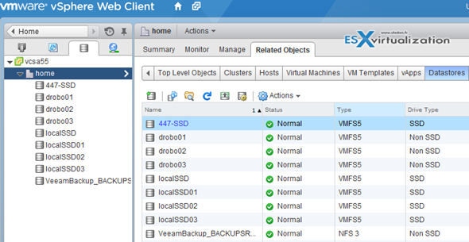

Simple and easy. By deleting the disk groups in each of my hosts I could recover the local disks.